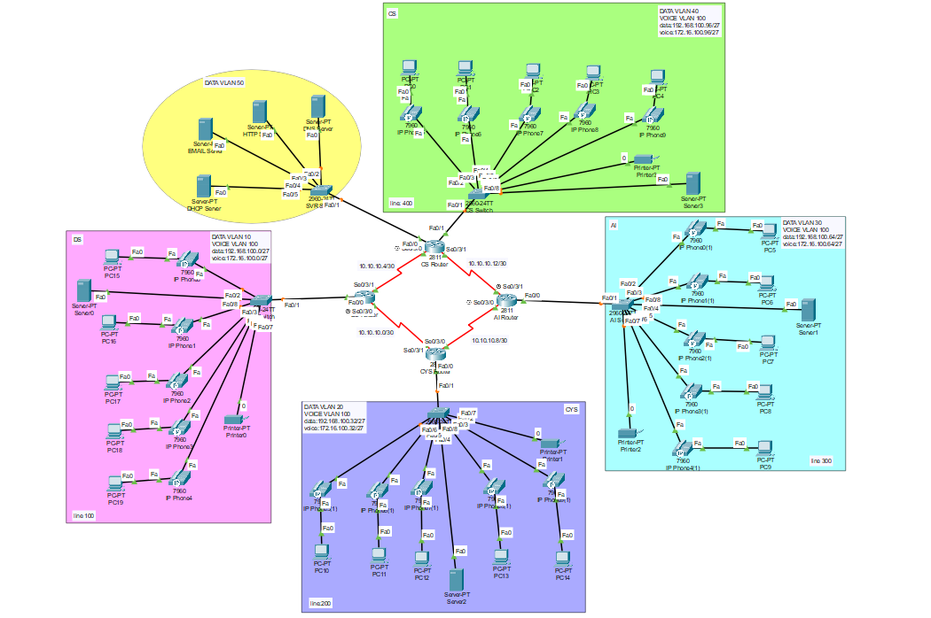

In today's interconnected world, communication is the cornerstone of success for any organization. Traditional telephone systems are rapidly being replaced by Voice over Internet Protocol (VoIP) systems due to their cost-effectiveness, scalability, and flexibility. This project aims to implement a VoIP phone system, leveraging computer networks, to streamline communication within an organization.

**DS Switch:**  
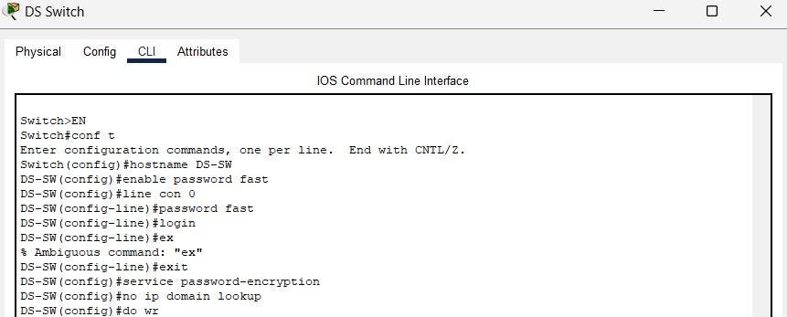

Data and voice vlan access:

**CS Switch:**  
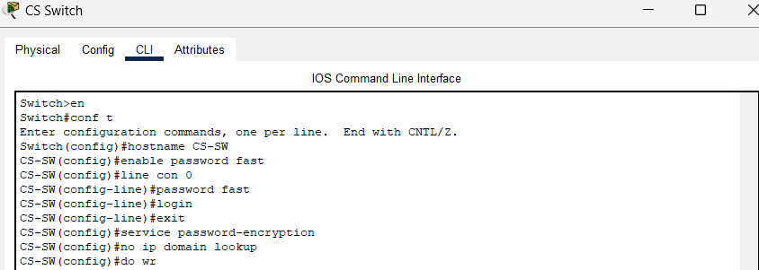

Data and voice vlan access:  
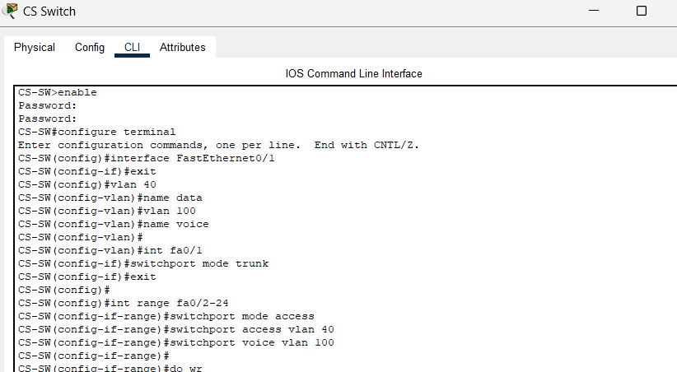

**CYS Switch:**  
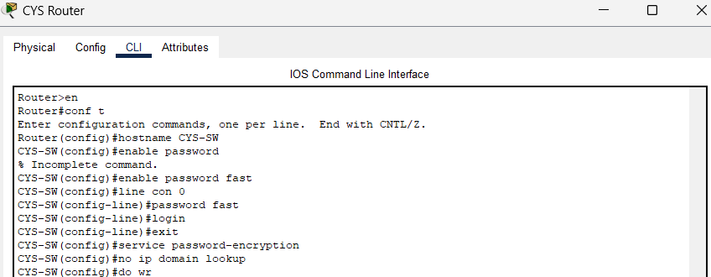

Data and voice vlan access:  
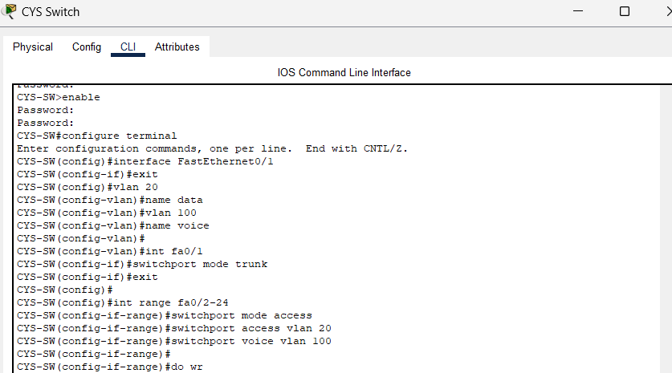

**AI Switch:**  
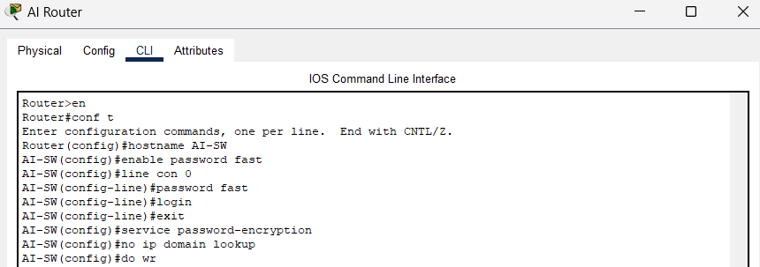

Data and voice vlan access:  
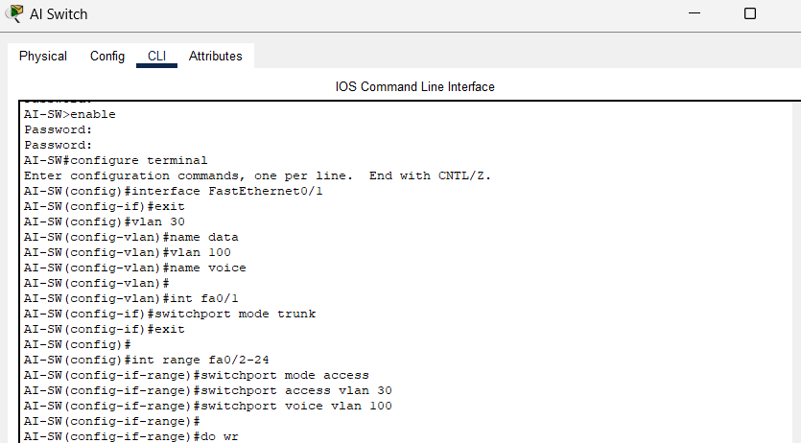

Server switch:  
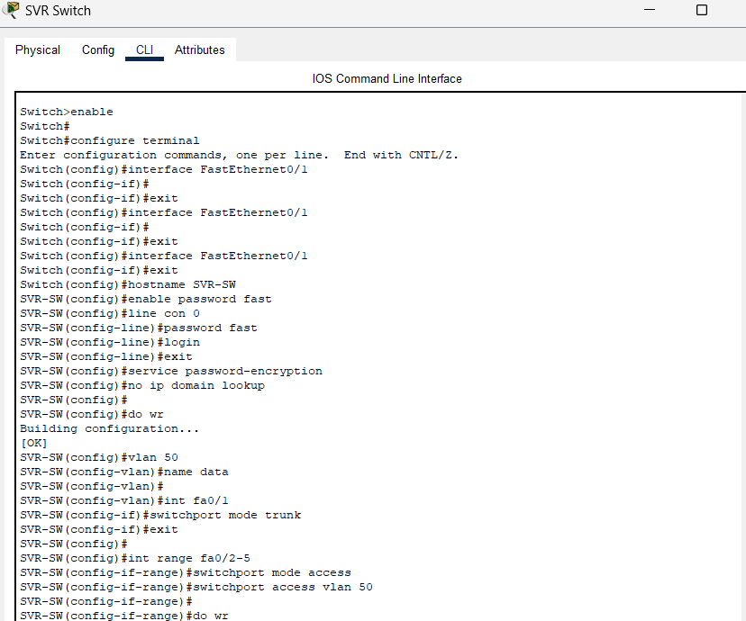

**DS Router:**  
ssh configuration:  
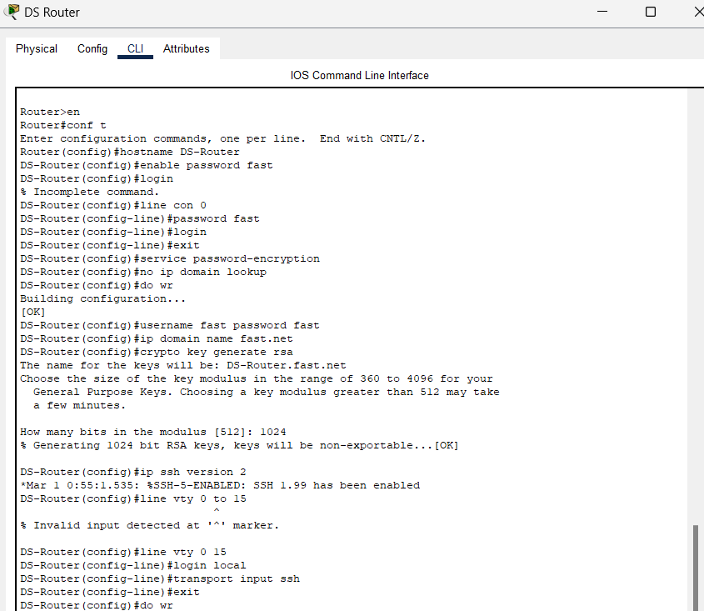

Dhcp voice configuration:  
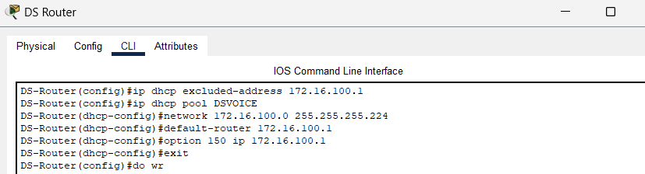

Encapsulation:  
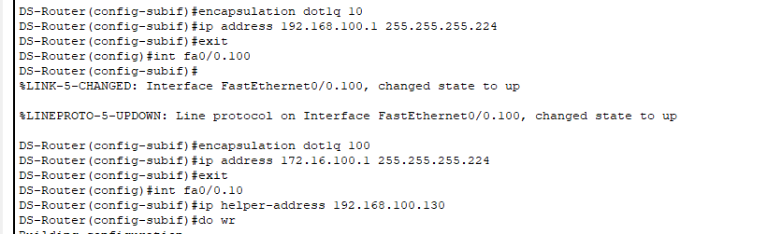

Ospf configuration:  
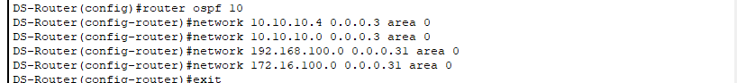

Voip configuration:  
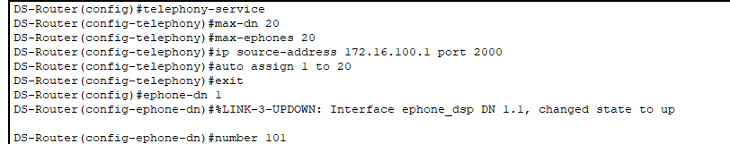

Dial peer:  
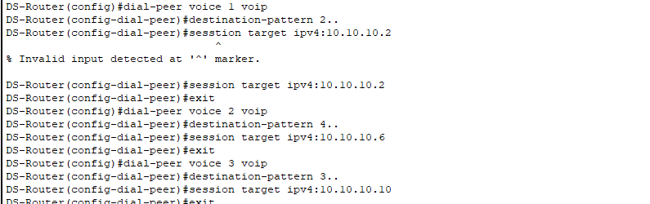

**CS Router:**  
ssh configuration:

Dhcp voice configuration:  
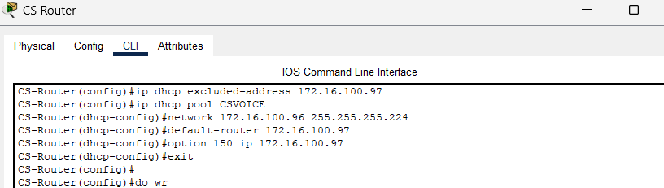

encapsulation:



Ospf configuration:  
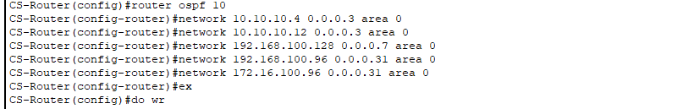

Voice   
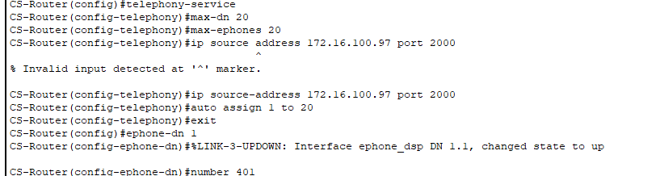

Dial peer:  
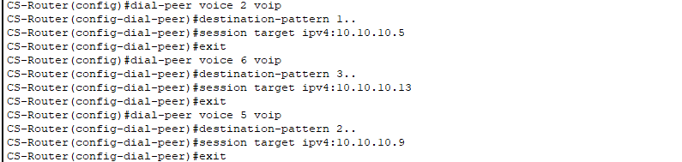

**CYS Router:**  
ssh configuration:

Dhcp voice configuration:  
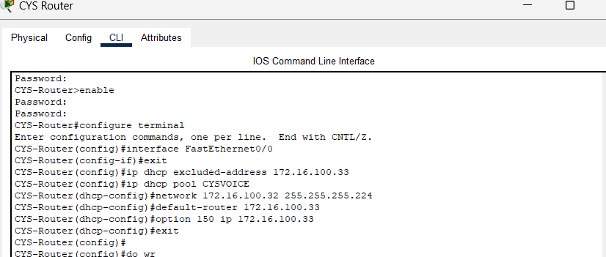

Encapsulation:

Ospf configuration:  
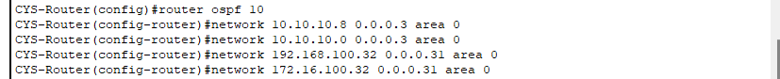

voice configuration:  
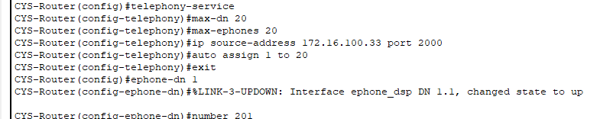

dial peer:  
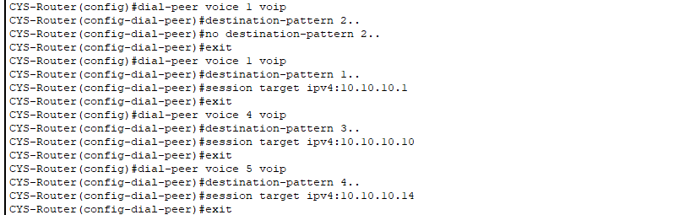

**AI Router:**  
ssh configuration:

Dhcp voice configuration:  
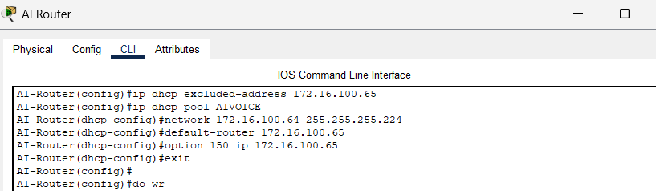

Encapsulation:

Ospf configuration:  
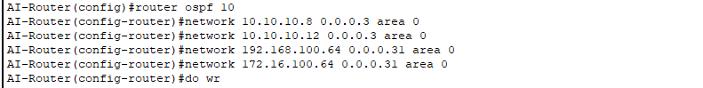

voice configuration:  
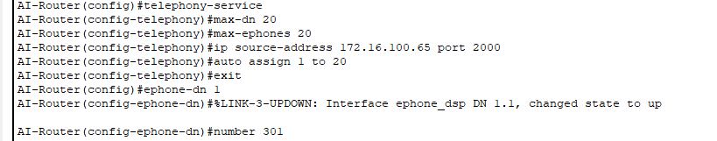

dial peer:  
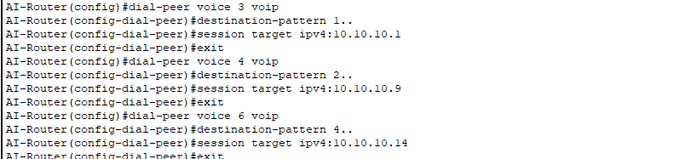

**Server ip addressing done through static method:**

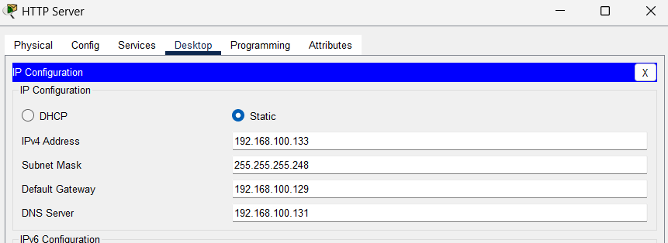

**DHCP Pools:**  
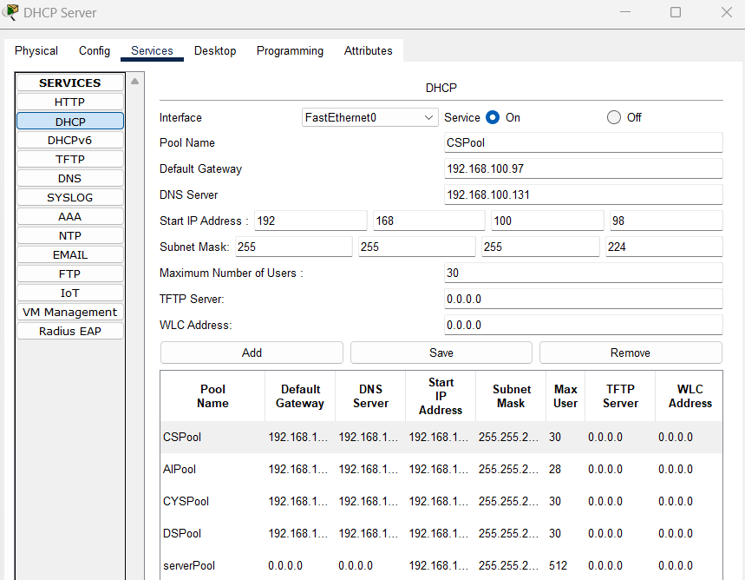

**Subnetting:**  
Each department has 21 devices (phones,pc,printer)

|  |  |  |  |  |  |
| --- | --- | --- | --- | --- | --- |
| **Department** | **Network Address** | **devices** | **Subnet mask** | **Host address range** | **Broadcast address** |
| DS | 192.168.100.0 | 21 | 255.255.255.224/27 | 192.168.100.1  To  192.168.100.30 | 192.168.100.31 |
| CYS | 192.168.100.32 | 21 | 255.255.255.224/27 | 192.168.100.33  To  192.168.100.62 | 192.168.100.63 |
| AI | 192.168.100.64 | 21 | 255.255.255.224/27 | 192.168.100.65  To  192.168.100.94 | 192.168.100.95 |
| CS | 192.168.100.96 | 21 | 255.255.255.224/27 | 192.168.100.97  To  192.168.100.126 | 192.168.100.127 |
| Server | 192.168.100.128 | 4 | 255.255.255.248/29 | 192.168.100.129  To  192.168.100.134 | 192.168.100.135 |

|  |  |  |  |  |  |
| --- | --- | --- | --- | --- | --- |
| **Department** | **Network Address** | **devices** | **Subnet mask** | **Host address range** | **Broadcast address** |
| DS | 172.16.100.0 | 20 | 255.255.255.224/27 | 172.16.100.1  To  172.16.100.30 | 172.16.100.31 |
| CYS | 172.16.100.32 | 20 | 255.255.255.224/27 | 172.16.100.33  To  172.16.100.62 | 172.16.100.63 |
| AI | 172.16.100.64 | 20 | 255.255.255.224/27 | 172.16.100.65  To  172.16.100.94 | 172.16.100.95 |
| CS | 172.16.100.96 | 20 | 255.255.255.224/27 | 172.16.100.97  To  172.16.100.126 | 172.16.100.127 |

|  |  |
| --- | --- |
| **router** | **Network address** |
| DS to CYS | 10.10.10.0/30 |
| DS to CS | 10.10.10.4/30 |
| AI to CYS | 10.10.10.8/30 |
| AI to CS | 10.10.10.12/30 |

Access any router from any pc:  
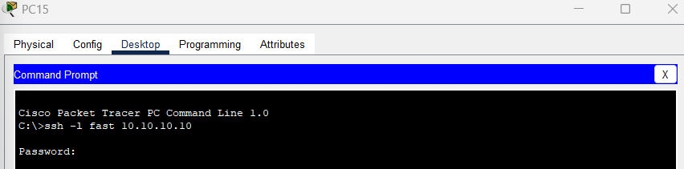

**SMTP email transfer:  
